**EXP NO 5: CREATE A SIMPLE CLOUD SOFTWARE APPLICATION FORLIBRARY BOOK RESERVATION SYSTEM FOR SIMATS LIBRARY USING ANY CLOUD SERVICE PROVIDER TO DEMONSTRATE SAAS**

**DATE:** 30/09/2025

**AIM:**

To Create a simple cloud software application for Library book reservation system for

SIMATS library using any Cloud Service Provider to demonstrate SaaS

**PROCEDURE:**

step1: Go to zoho.com.

step 2: Log into the zoho.com.

step 3: Select one application step.

step4: Enter application name as library book reservation system.

step 5: Created new application as library book reservation system.

step 6: Select one form

step 7: The software has been created.

**OUTPUT:**

**Form 1- Book Catalog Form**

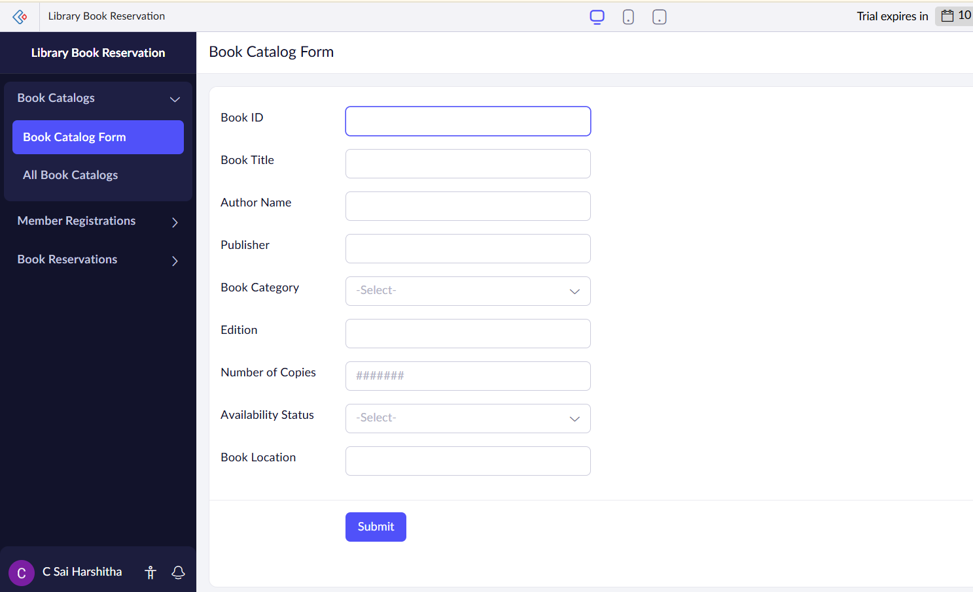

**Form 2- Member Registration Form**

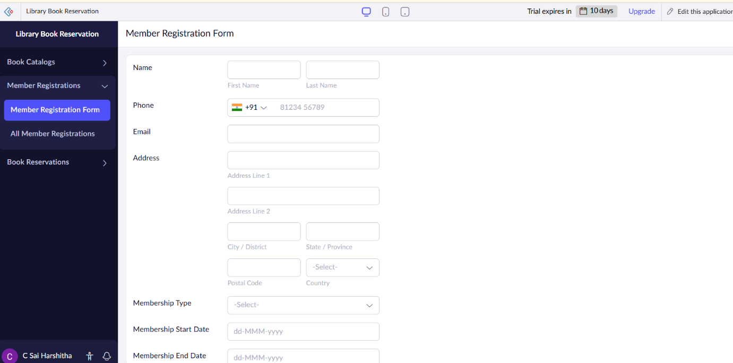

**Form 3- Book Reservation Form**

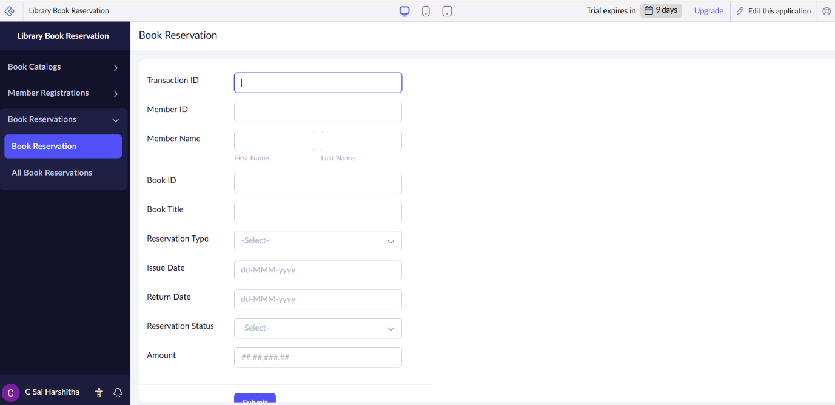

**Form 1- Book Catalog Form**

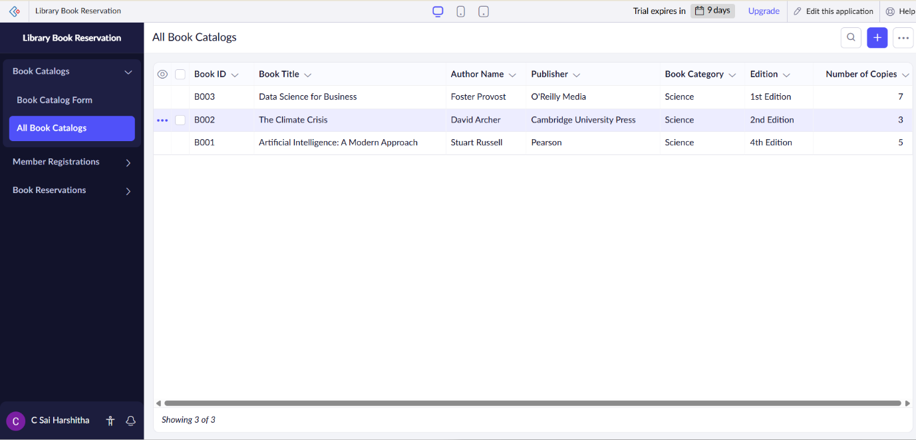

**Form 2- Member Registration Form**

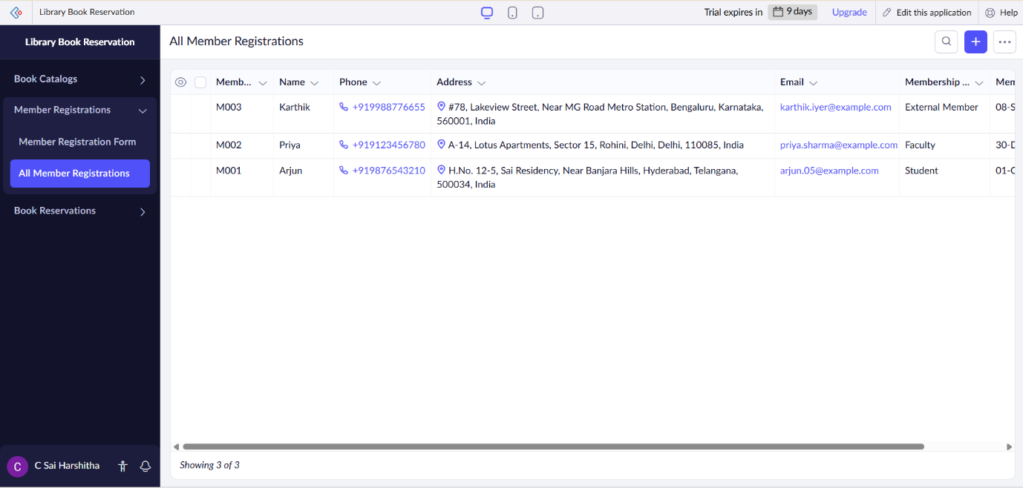

**Form 3- Book Reservation Form**

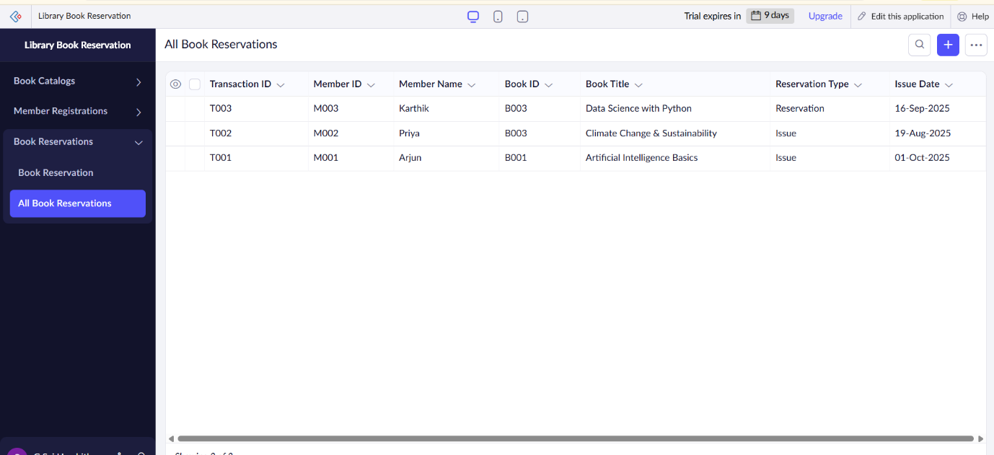

**RESULT:**

The **Library Book Reservation System** application was successfully created using **Zoho Creator (Cloud SaaS platform)** with the following forms:

* **Book Catalog Form**
* **Member Registration Form**
* **Book Reservation Form**

This demonstrates **SaaS**, as customers can register, view available cars, make bookings, and check their booking status entirely online without installing any software.